Overview:
Monkeypox is an emerging viral disease, but the risk of infection in the workplace is very low. Some precautions, however, are considered for non-healthcare and non-isolation housing custodial work, since monkeypox can be spread via contact with contaminated linen and other surfaces that make contact with the skin. Monkeypox is more of a contact-transmission exposure risk, not so much an aerosol exposure risk (like COVID-19). Review general monkeypox information in the provided links below.

Instructions:
Review, “Task Description”, “Type of Hazard” questions, follow “Type of Control” recommendations.

Additional Information:
UHS Monkeypox Information
CDC Monkeypox Information

Contributors:
Patrick Kaulback - EH&S
Stephanie Ngan - Safety Officer, Division of Student Affairs
Mark Kinnard - Director, RSSP Custodial Services

Created:
August 12, 2022

JSA Library Number:
HCS-MIP-01
For more information about this JSA, contact EHS@berkeley.edu.
- Restroom Cleaning | Contact with contaminated surfaces  Toilet seats, appliance handles, door handles | - PPE including: Disposable gloves, uniform with long-sleeved shirt or optional Tyvek suit  - Surface disinfection with approved disinfectant (can be same one used for COVID-19 or other from EPA List Q
- Waste Handling | Dispersion of shedded lesions  Waste containers may contain items that have been in contact with an infected person’s skin. | - Do not shake waste containers  - Seal trash bags before handling them  - PPE including: face covering or voluntary N95 use; disposable gloves, long-sleeved shirt, or optional Tyvek suit
3. General Facility Cleaning | Dry Sweeping, Dusting, Vacuuming  Airborne dispersion of infected particles during dry methods of cleaning. Not a significant hazard in the workplace outside of isolation housing and healthcare facilities. Community prevalence of monkeypox is very low. | - Use wet-cleaning methods that avoid creating airborne particles, e.g. mopping, spray wipe, damp cloth, etc.  - Use vacuums equipped with HEPA filters  - PPE including: face covering or voluntary N95 use; disposable gloves, long-sleeved shirt, or optional Tyvek suit
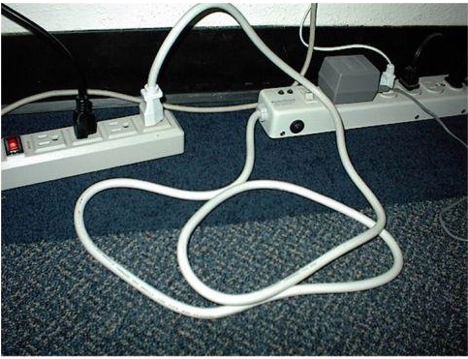  4. Linen Handling | Dispersion of shedded lesions and contact with contaminated linens  Mainly a hazard in isolation housing and healthcare facilities for linens such as bedding, towels, cloth napkins.  Table linens are a low risk, but all linens should be handled in the same way. | - Do not shake soiled linens  - Transport soiled linens in closed bags  - Routine washing/drying is appropriate  - PPE including: face covering or voluntary N95, safety glasses, disposable gloves, long-sleeved shirt, or optional Tyvek suit.  - Wash hands after task
5. Laundry Room Service | Dispersion of shedded lesions in soiled linens/clothing  Exposure risks may come from handling linen/clothing left behind from unknown sources, and from cleaning laundry rooms with dry methods such as sweeping, dusting, and vacuuming. | - Do not disturb unknown linens left behind by others if possible.  - When handling linens/clothing, do not shake them  - If linens/clothing will be thrown away, put them in a plastic trash bag, seal it, and put it in a landfill container.  - Wear PPE including: face covering or voluntary N95, disposable gloves, safety glasses, long-sleeved shirt, or optional Tyvek suit.  - Use wet-cleaning methods such as mopping, surface sprays, damp cloths, etc.  - Use vacuums with HEPA filters  - Disinfect potentially contaminated surfaces with approved disinfectant from EPA List Q.

