Overview

This guide serves as an example and is presented with permission from LBNL. There are many types of pressure vessels so this serves as a template that allows you to replace the images to meet your specific needs.

Visual comparison guides are effective for certain applications, when for example, researchers may otherwise not know what is acceptable or not. We might state “look for excessive wear or corrosion” but these are partly qualitative descriptions that people can interpret differently. Excessive wear to one person may not be the same to another. The visual guide helps to solve that variability.

Continued on next page

Pressure Vessel Visual Inspection Guide

In Good condition | Possible corrosion (have checked)
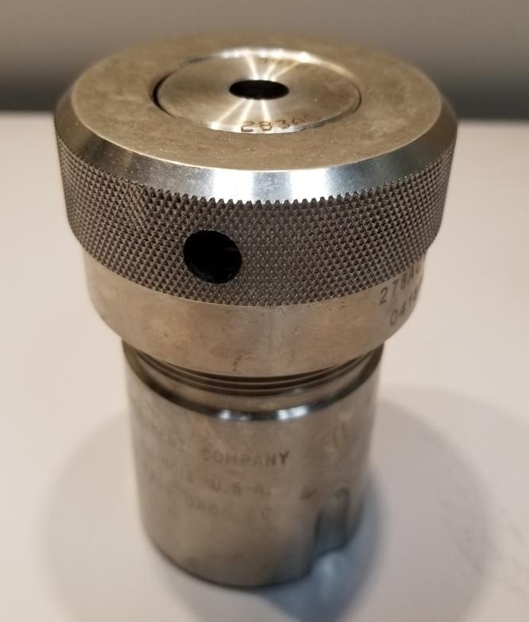 | 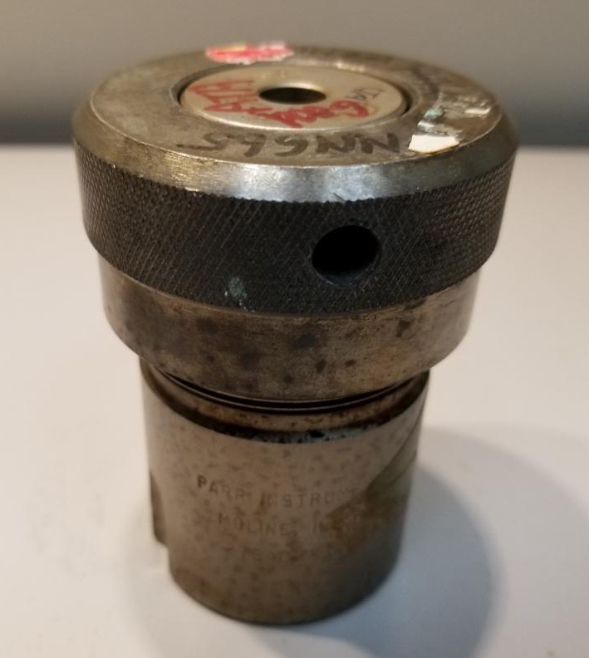
In Good condition | Possible corrosion (have checked)
 | 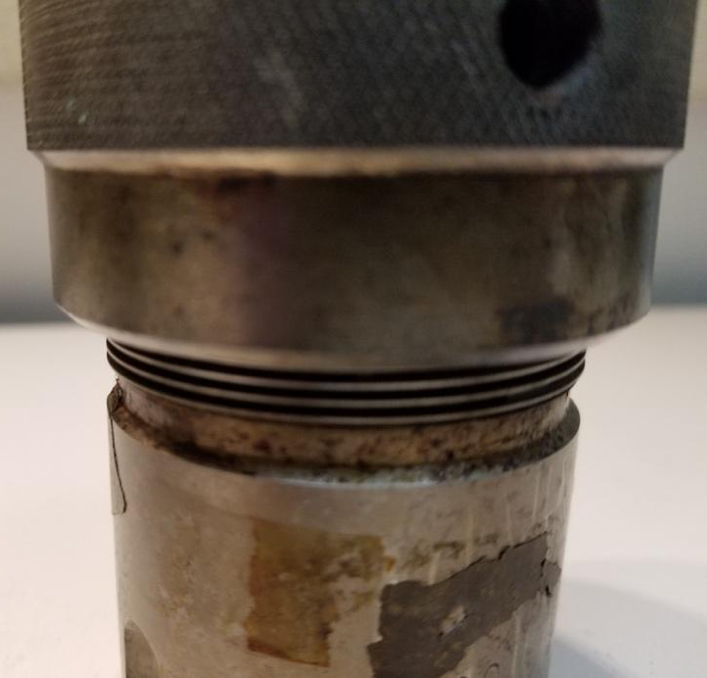

Example: Pressure Vessel Visual Inspection Guide

In Good condition, but could be cleaner | Possible corrosion (have checked)
 | 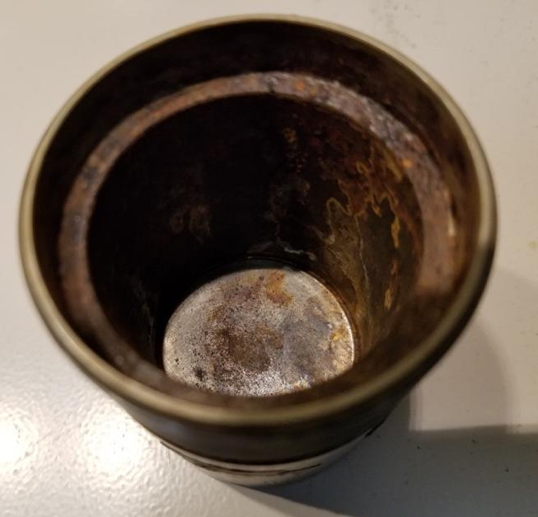
In Good condition (flat bottom piece) | Bottom piece is bowed from over pressure
 | 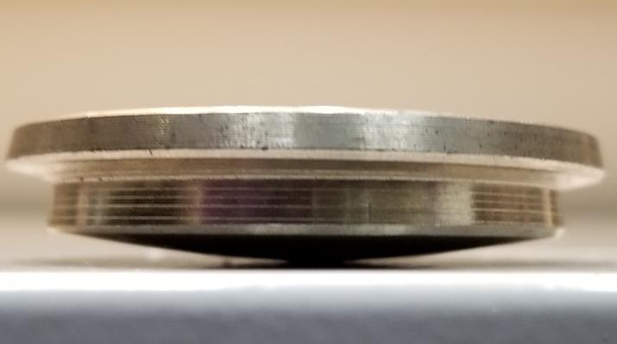
Good condition corrosion and rupture disk | Worn corrosion and rupture disk
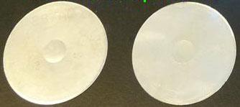

Pressure Vessel Visual Inspection Guide

In Good condition (Teflon liner) | Poor condition (Teflon liner) -discolored
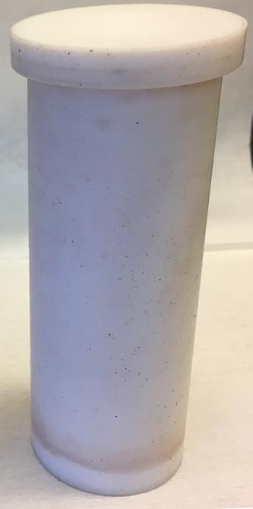 | 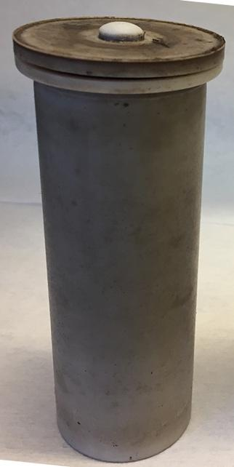
In Good condition (Teflon lid) | Poor condition (Teflon lid)
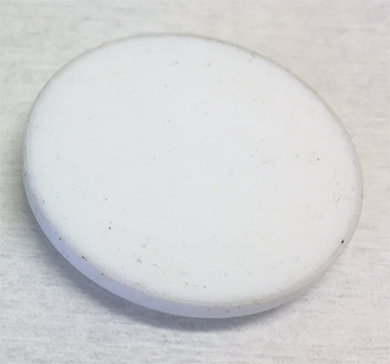 | 