Overview

This guide serves as an example and is presented with permission from LBNL. There are many types of pressure vessels so this serves as a template that allows you to replace the images to meet your specific needs.

Visual comparison guides are effective as a quick review of processes. It is recommended to keep these near relevant equipment. Visual guides can be useful for new researchers learning to use the equipment or as a refresher for those who do not regularly use the equipment. People may interpret qualitative descriptions differently so a visual guide helps to solve that variability.

Continued on next page

STEP 1:  Insert bottom | STEP 2:  Insert cup | STEP 3:  Fit Teflon lid | STEP 4:  Place both disks
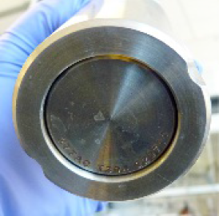 | 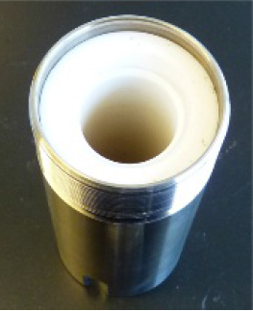
Insert bottom disc so that part numbers are visible on the outside | Insert pre-loaded cup. push bottom disc up to meet the cup then slide both to bottom. | Place Teflon lid on top | Add corrosion disc.  Then add rupture disk.

STEP 5: Bottom Pressure plate & spring | STEP 6:  Top pressure plate | STEP 7:  Fit screw cap | STEP 8:  Tighten cap
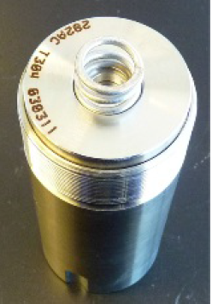 | 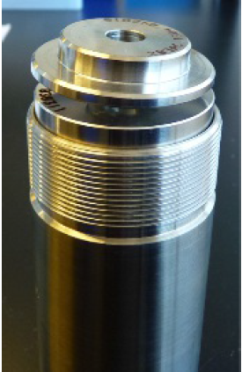 | 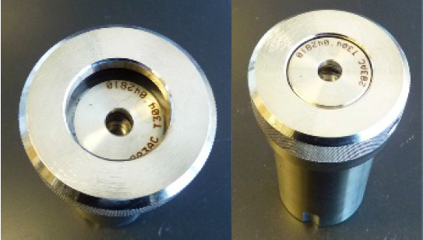
Place the bottom pressure plate on top of the rupture disc, so that the part number is facing up. Set the spring in the depression. | Add the upper pressure plate so that part number is facing up | Place screw cap on top. | Tighten by hand. Then use the provided tool (if your vessel requires it) and tighten an additional 1/8 of a turn. Do NOT overtighten!

Video showing assembly process
https://goo.gl/9YLfZU
Photo Credit: Photos from MFD

